Docx4all – basic features

This document shows the basic set of docx featureswhich are working in docx4all.

This is an unstyled paragraph.

# This is style Heading 1

Left indent

Centre

Align Right

Justified text

Indented indented indented indented indented indented indented indented indented indented indented indented indented indented indented indented indented indented indented indented indented indented indented

First line indent, Left indent, Hanging indent aaa bbb aaa bbb aaa bbb aaa bbb aaa bbb aaa bbb aaa bbb aaa bbb aaa bbb aaa bbb aaa bbb aaa bbb aaa bbb aaa bbb

Normal

A parapgraph with 10 points spacing before, 20 points after.

Normal

Font styles Aerial Black

Font styles 18 point

Font styles **bold**

Font styles *italic*

Font styles underline

Bullets

* Level 1
  + Level 2

Numbering

1. Level 1
   1. Level 2
      1. Level 3

Here is some change tracking. An insertion Followed by.

This line contains a soft return  
and here it continues…

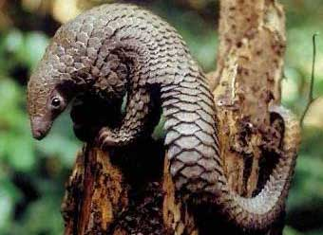

Gif (scaled):

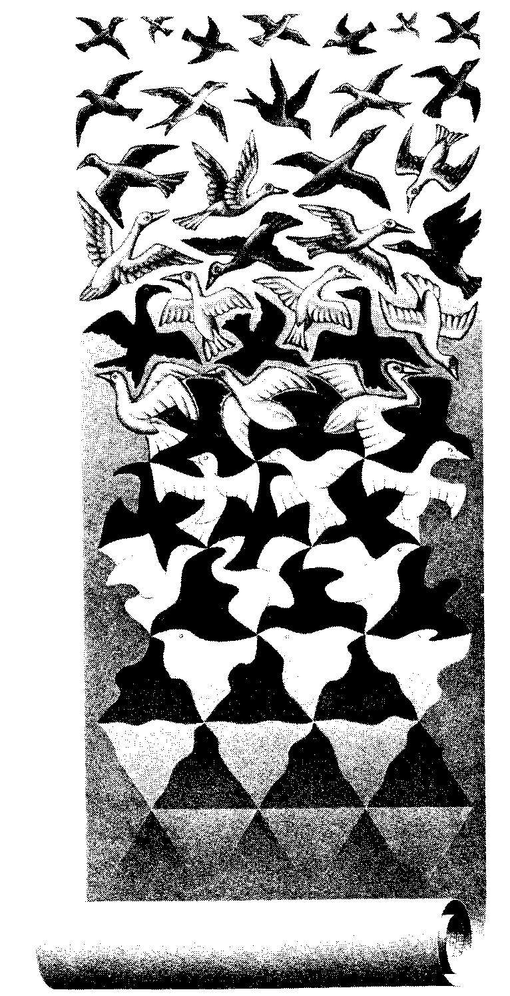

Png (from <http://davidpritchard.org/images/pacsoc-s1b.png> )

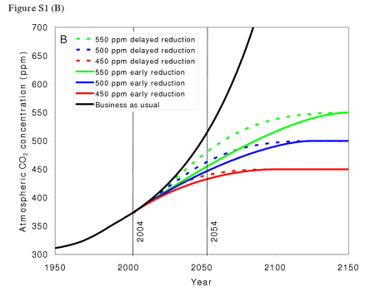

Finally, a table:

|  |  |  |
| --- | --- | --- |
| Cell text |  | Shaded grey |
| Vertical merge |  | Shaded grey |
|  |  |
|  | Horizontal merge | |

We should also have a content control in here (sdt):

This is a rich text content control.